Media Bazaar
User requirements document

Content map

Content map 1
Functional requirements 1
Our Team 2
Non-functional Requirements 2
Use Cases 3

Functional requirements
User1 – employee
User2 – management team
User3 – administration team
- User1 should be able to check their schedule.
- User3 should be able to manage the employees
- User2 should be able to change the schedule for User1
- User2 should be able to change the stock and make re-shelf requests
- User3 should be able to create employee accounts
- User3 should be able to delete and change employee accounts
- All users should be able to login to the system using their credentials created beforehand
- User2 should be able to check statistics about stock such as most popular stocks
- User1 should be able to submit re-shelf requests
- User2 should be able to respond to the re-shelf requests made by User1
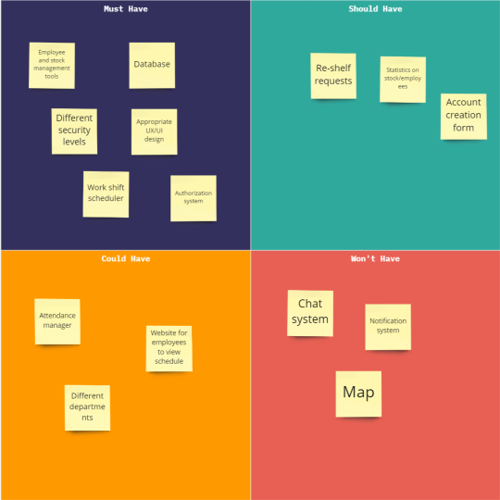

OUR Team
- Draganova,Denitsa – Developer
- Petkov,Mario – Developer
- Garkov Aleksandar– Developer
- Nikolov,Grigoriy – Developer

non-functional Requirements
The application must be:
- Stable – the application will not have bugs and will not crash easily.
- Secure by design – the team will try to avoid the possibility of data leaks. Security will be taken into account with our decisions
- Flexible – the user can easily operate within the program
- User-friendly- the user can easily operate within the program. Short learning curve.

Use Cases
Use Case 1: Change employee’s working schedule
Actor: Manager
Main success scenario:
1. Actor enters their credentials into a login form
2. System allows the actor to login
3. Actor finds the department of the employee in the search bar
4. Actor opens the employee’s schedule in edit mode
5. Actor changes the information in the schedule and saves it
6. System confirms the changes and closes
Extensions:
2a: Actor enters wrong credentials
1.System displays error message
3a: The system does not find employees
1.System displays error message and redirects to another page, where new employees can be inserted.
Use Case 2: Employee logs to see his schedule
Actor: Employee
Main success scenario:
1. Actor enters their credentials into a login form
2. System allows the actor to login
3. Actor enters the scheduler and can see the shifts that he is assigned to
4. Actor posts a message with which he drops the shift.
5. System confirms the changes and closes
Extensions:
1a: Actor enters wrong credentials
1.System displays error message

Use case 3: Manager checking stock statistics
Actor: Management team employee
Main success scenario:
- Actor enters their credentials into a login form
- System logs in the actor
- Actor clicks on the “Statistics” tab
- Actor can choose which statistics to open
- Actor chooses “Stock statistics”
- Actor can see the most popular products
Extensions:
1a: Actor enters wrong credentials
- System displays error message
Use case 4: Delete employee accounts
Actor: Administration team
Main success scenario:
- Actor enters their credentials into a login form
- System logs in the actor
- Actor clicks on the “Employees” tab
- Actor chooses an employee from the list of employees
- On their right, the actor can see an overview for the current employee and buttons for deleting the employee
- Actor clicks on the “Delete” button
- Actor is asked to make a confirmation about their choice
- Actor confirms their action (clicks on a button “Confirm”)
Extensions:
2a: Actor enters wrong credentials
- System displays error message
8a: Actor chooses wrong employee
- Actor doesn’t confirm their action
Use case 6:

